Keyword:

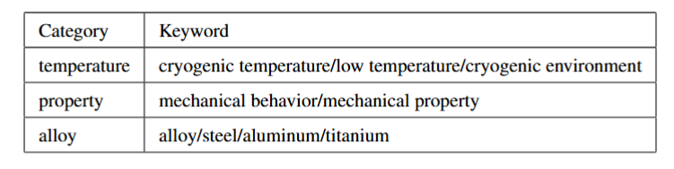

Advanced search formulas:

(TI=( （"cryogenic temperature\*" or "Low temperature\*" or “cryogenic environment” ) and （Mechani\* or "Mechanical behavior\*" or "Mechanical propert\*") and (alloy\* or steel\* or Aluminium \* or Titanium \*))) OR （AB=( （"cryogenic temperature\*" or "Low temperature\*") and （Mechani\* or "Mechanical behavior\*" or "Mechanical propert\*") and (alloy\* or steel\* or aluminium\* or Titanium\*))) OR（ AK=( （"cryogenic temperature\*" or "Low temperature\*") and （Mechani\* or "Mechanical behavior\*" or "Mechanical propert\*") and (alloy\* or steel\* or aluminium\* or Titanium\*))）